

Steward Communications Committee

Handbook

2018-2019

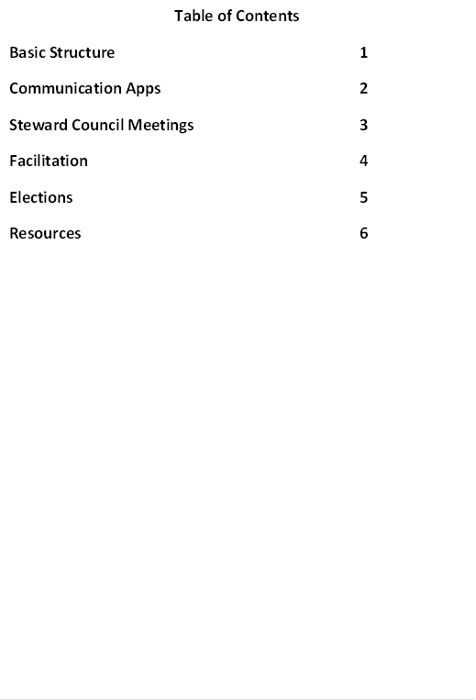



**Basic Structure**

The **Steward Communications Committee** is made up of 10 total Stewards, with 2 Stewards representing a cluster of departments. The SCC is responsible for facilitating Steward Council meetings, drafting agendas for these meetings, organizing food prep for SC meetings, and disseminating important information to their department clusters.

**The SCC does not have additional decision-making authority over the Steward Council, their role is to effectively organize meetings and keep our Stewards informed on what they need to know to perform their role as a Steward.**

**Departments are clustered as follows:**

**Red**: EECS, Mathematics, MIME, Nuclear Engineering, & Statistics

**Blue**: Applied Anth., CSSA, Education, Environ. Arts & Humanities, HDFS, Psych. Sciences, Public Policy, SHPR, SWLF, & WGSS

**Green**: Biochem & Biophysics, Business Admin, Design & Human Environ., Environ. & Molecular Toxicology ,Environmental Sciences, Forest Ecosystems, Forest Engineering, Integrative Bio, Microbiology, Pharmacy, Physics, Wood Science

**Yellow**: Bio & Ecological Eng., CBEE, Chemistry, Civil & Construction Engineering, Materials Science, Water Resources

**Purple**: Animal & Range. Sciences, Applied Econ., BPP, CEOAS, Crop & Soil Science, Fisheries & Wildlife, Food Science, Horticulture, Speech Comm., Veterinary Sciences

Two (2) Stewards from each cluster chair the SCC, and are elected to their position on the committee.

The SCC directly communicates with the VP of Organizing, VP of Membership, and our staff organizer to maintain strong channels of communication between the Steward Council and Executive Council.

**Communication Apps**

**Slack**:

* Online communication app that allows for easy group and individual messaging.
* Slack has “channels” with specific topics for cataloguing information. Ex: Materials is a channel in our SCC slack where you can find info like our steward contact list.
* You can individually message another user on slack if you want to have a direct communication with them.
* You can ping another user when you send a message so that they know it requires their attention. Simply use the @ symbol and a list of names will come up.
* You can also set the notifications for slack, so that during certain hours notifications are turned off or you’re following only a certain channel.
* This tutorial video is helpful: <https://www.youtube.com/watch?v=9RJZMSsH7-g>

**Hustle:**

* An app that allows you to send a large number of personalized messages in a short amount of time.
* We will ask you to participate in Hustle campaigns periodically to connect with workers we haven’t been able to reach.
* Hustle will have pre-loaded personalized messages and a list of contacts. All you do is press send, and another contact appears. One Hustle user can send up to 1,000 individual messages in an hour with this app.
* When people respond, you will have the ability to respond with a number of pre-loaded text responses.
* You can also modify any message you want to send.

**Steward Council Meetings**

The SCC takes on the following role in SC meetings:

* **Create an agenda** (you will communicate regularly with the VP of Organizing and VP of Membership to be updated on union topics. Also, all our EC meeting minutes are published on our website cge6069.org/category/minutes)
* **Announce meetings** (you will help us publicize meetings and ensure that the agenda is shared with other stewards prior to a meeting. The steward email is [stewards@cge6069.org](mailto:stewards@cge6069.org) and you will be asked to reach out to stewards form within your cluster)
* **Get volunteers** (we ask stewards to help setup Westminster for meetings and with any food preparation)
* **Facilitate meetings** (we operate by consensus, and this requires that we have good facilitators for moving our meetings along. You and one other SCC officer will be a facilitator for at least one SC meeting, and this responsibility will rotate among the stewards on the SCC)
* **Help spread the info!** (you will help us publicize meeting minutes, make sure your steward clusters are updated on our union’s activities, and just in general help us improve our overall communications).

**Facilitation**

An explanation of our consensus process can be found in the Steward Handbook.

**Tips for good facilitation:**

* *Do not dominate conversation, stimulate it.*
* *Equalize participation.* Meetings are so boring when you only hear the same five people talk every time.
* *Clarify Process when necessary.* Summarizing where the conversation is helps participants have a shared understanding of a proposal.
* *Honor the Agenda Contract.* Help us stay on task, we created the agenda for a reason.
* *Assume good will.*

**Techniques for facilitation:**

* *Take Stack.* One facilitator should keep stack. This means taking note of who has their hand raised and the order in which this happened, so then you can call on people when it’s their turn. It also helps to rearrange the stack sometimes if one person keeps putting themselves on stack that’s already spoken a lot.
* *Temperature Checks.* Before proposing consensus, a temperature check of a simple thumbs up, thumbs down can help see where the group is at and whether we should proceed with a consensus decision.
* *Silence.* Sometimes it helps when things are getting tense or too complicated to call for a moment of silence to collect our thoughts.
* *Reformulate the proposal:* Restate a proposal to help simplify it and make it clear.
* *Call for Consensus:* As facilitator, you should try to predict when the group is ready to finalize a decision through a consensus vote. Before calling consensus, ask if there are any objections or amendments to the proposal.

**Elections**

**Steward Council:**

* Elections take place in winter term.
* Kick-off happens at the winter GMM.
* Elections are held online for two weeks.
* Each department receives 1 steward per 10 workers to represent their department.
* Workers within the specific department vote for their steward representatives.

**Steward Communications Committee:**

* After winter election of stewards, an internal steward election for the SCC occurs.
* The stewards nominate and elect the representatives to serve on the SCC.
* Kicks off at the spring GMM along with Executive Council election.
* Online election open for two weeks.

**Resources**

**Steward Handbook:** General summary of steward roles and responsibilities.Found online at <http://cge6069.org/stewards/steward-handbook/> Print versions available at CGE office.

**Steward Toolkit:** Supplemental resource guide with templates for office visits, orientations, FAQs, grievances, and more! Really useful!

Found online at <http://cge6069.org/steward-toolkit/> Print versions available at CGE office.

**Knack:** A database of all graduate workers with a GTA or GRA at OSU. You can use Knack to lookup any department or individual grad worker and see if they are a member, if they’ve been talked to, if they are involved in a caucus, ect.

Go to: cge6069.org/organize

Login: [your preferred email or osu email]

Password: solidarityforever

**Executive Council:** All meetings of the Executive Council are listed on our calendar on the website, and are open to all members. The EC email is [ec@cge6069.org](mailto:ec@cge6069.org) You should feel free to communicate regularly with the EC, and particularly our VP of Organizing and VP of Membership.